Student worksheet

2.2 Relationships between organisms may be beneficial or detrimental

Pages 18–21 and 181

Relationships between organisms in ecosystems

1 What are the 3 types of relationships between organisms in the same species? Give an example for each.

i.

ii.

iii.

2 Why might organisms of the same species need to collaborate?

3 What is symbiosis?

4 Between what types of organisms is there symbiosis?

5 Name the three types of symbiotic relationships.

5 Define and provide an example of the following:

a commensalism

b mutualism

c parasitism

6 What are the two non-symbiotic relationships? Describe the relationship and give an example of each.

i.

ii.

7 Explain why these are non-symbiotic relationships.

8 What types of relationships are depicted in the following pictures? Explain why you think this.

|  |  |  |
| --- | --- | --- |
| Picture | Relationship | Explanation |
| SW0217_01439-r |  |  |
| SW0218_01439-r |  |  |
| SW0219_01439-r |  |  |
| Image result for lions and hyena |  |  |
| Image result for baby birds in a nest |  |  |
| Related image |  |  |

9 Find a word

Find the words in the puzzle of letters below that will fit the clues given.

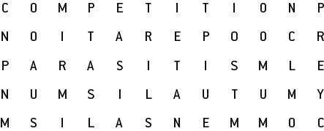

|  |  |
| --- | --- |
| WORD | CLUE |
| C\_ \_ \_ \_ \_ \_ \_ \_ \_ \_ | \_\_\_\_\_\_\_\_\_\_\_\_\_\_ occurs when organisms need the same limited resource. |
| P\_ \_ \_ \_ \_ \_ \_ \_ \_ | The relationship where one organism lives in or on the body of another is called \_\_\_\_\_\_\_\_\_\_\_\_\_\_\_\_. |
| P\_ \_ \_ | In a predator–\_\_\_\_\_\_\_ relationship, one organism eats another. |
| C\_ \_ \_ \_ \_ \_ \_ \_ \_ \_ \_ | \_\_\_\_\_\_\_\_\_\_\_\_\_\_\_\_ is a relationship in which one organism benefits and the other organism is not affected. |
| M\_ \_ \_ \_ \_ \_ \_ \_ | The relationship between two organisms where both benefit is called \_\_\_\_\_\_\_\_\_\_\_\_\_\_\_\_\_. |
| C\_ \_ \_ \_ \_ \_ \_ \_ \_ \_ | The collaboration between two organisms requires \_\_\_\_\_\_\_\_\_\_\_\_\_\_ in order to survive. |

Extend your understanding

10 Explain the following terms and give an example of a real world situation where these may occur:

a Intraspecies competition

b Interspecies competition

c Competition exclusion principle